**Analysis**

For game like snakes and ladders goal will be to create a computer application which can control by one player with a graphical user interface. First of all we have to find the minimum number of dice throws to reach the last square (50th) which means destination. And also we have to generate dice number and position of the player as well as each number of squares player is in, specified number of snakes and ladders initial position and length and print out the result at each turn. If the player found a ladder or snake print the result that from which position to which which position player should move.

Also good interface design with introduction message for the application which can understand easy for the user.

**Specification**

Input – Asking player’s name

Input - Roll the dice for any random integer from 1 to 6

Output - Move player position forward using the random number

Output - If found a snake move down the player position to square with snake tale

Output – If found a ladder forward the player position to top of the ladder

Output – If player position more than 50, Position = (Position – 50)

Output – If player position 50 show the message “Congratulation! You won!

**Create the design**

The Snakes and Ladders game starts with the header image and same time asking the player’s name to input. After input the name of the player it show’s on the game board with the welcome message. There is an option for roll the dice and get the random integer between 1 to 6. By “Roll Dice” button. And also buttons for introduction, feedback and exit the game. About the game if not introduction of the game can get when click the introduction (“i”) button. And user can give feedback comments for the game using “Feedback” button option. Once user comment and submit the feedback, window will close and record will be recorded. All buttons have been replaced with images. To create the game board has been used image files for each square for give user a better understand and also an attractive interface design. As well as when player moving position to position there is a game piece moving position according to dice roll. When player found a snake displays a message to indicate that player has been snake bitten and player position will goes to the square with snake tale. Also when player found a ladder displays a message that player found a ladder and position goes to square with top of the ladder.

**Implement the design**

The algorithm of the game is defined by the Pseducode

Pseducode

1. Start the program
2. Popup window for prompt the player’s name
3. Display the name on welcome message of the interface
4. Import modules (tkinter, PhotoImage and other libraries)
5. Declare variables dice dice number, player position, snakes and ladders and moves
6. Define snakes positions and ladder positions
7. Define functions for create a graphical user interface
8. Create a window and set title
9. Create a label and load image as the header
10. Create a button to popup windows for introduction message
11. Create a button to popup window for feedback comments with a button for submit, when user give comment

Print (“Thank you! Your feedback is”, txt)

1. Create a button named “Roll Dice” for rolling dice function
2. Create a button named “Quit Game” for exit the game
3. Set a label to show which number that dice rolled after every roll
4. Set another label to show after roll once which square to player should move including snake bites and ladder climbs
5. Define all the image files used in the interface
6. Create 50 labels that display the game board and put them in a grid
7. Set the variables to 0
8. Define a function for roll the dice
9. Calculate dice numbers any random integer from 1 to 6
10. Use the random number to move player positions

Pos = pos + dice

1. If player position more than 50,

Pos = 50 – (poss – 50)

1. If player found a ladder,

If Pos = 3

Pos = 8

Print (“Wow! It’s a ladder, move to 8”)

Elif Pos = 6

Pos = 26

Print (“Wow! It’s a ladder, move to 26”)

Elif Pos = 14

Pos = 22

Print (“Wow! It’s a ladder, move to 22”)

Elif Pos = 32

Pos = 49

Print (“Wow! It’s a ladder, move to 49”)

1. If player found a snake,

If Pos = 28

Pos = 13

Print (“Oopz!,It’s a snake, go back to 13”)

Elif Pos = 39

Pos = 34

Print (“Oopz!,It’s a snake, go back to 34”)

Elif Pos = 48

Pos = 44

Print (“Oopz!,It’s a snake, go back to 44”)

1. Rest all the squares to original images
2. When player move position to position display a image with game piece to indicate the position
3. If player reach position 50

Print the message “Congratulation! You won!”

and set position and moves to 0

1. End of the program when user click “Quit Game”

**Test/Debug the program**

After written all codes we have to test the program for check is it working perfectly or not. As python is very sensitive for errors even simple errors like syntax errors cause for huge issues and can be break the program. Study all the errors as python shows where is it and make them correct until errors left.

**Maintain the program**

After make sure program work successfully and publish it, there is a option called “Feedback” So user can give any feedback to the program and it will be recorded. It will help for make implementation from the feedbacks received from the users.

**Source Code**

import random

import tkinter.simpledialog

from tkinter import *

from tkinter import PhotoImage

#Feedback text to show when click on the "Feedback" button

FEEDBACK = """

Enjoyed the game? It's feedback time,

☆☆☆☆☆

Please comment your experience with the game for improvements.

We appriciate your feedback ☺ Thank you! """

#Introduction text to show when click on the "Info" button

INTRO = """

★ ☆ ✮ ✯ ★ ☆ ✮ ✯ ★ ☆ ✮ ✯ ★ ☆ ✮ ✯ ★ ☆ ✮ ✯ ★ ☆ ✮ ✯ ★ ★ ☆

▁ ▂ ▃ ▄ Introduction ▄ ▃ ▂ ▁

This is one player Snakes and Ladders game.

Game board includes 50 blocks with 3 snakes and 4 ladders.

There is an option calls "Roll Dice".

Player should Roll the dice for move the position.

If player met ladders can climb up positions faster.

Player who reach the 50th position will be declared as the winner.

♚ ♛ ♜ ♝ ♞ ♟♚ ♛ ♜ ♝ ♞ ♟♚ ♛ ♜ ♝ ♞ ♟♚ ♛ ♜ ♝ ♞ ♟♚ ♛ """

#define variables

dice=0

pos=0

#Function to roll the dice and move player

def rollTheDice():

#define globals for allow access to variables of a function and allow access to each other variables

global dice,pos,window

global n1,n2,n3,n4,n5,n6,n7,n8,n9,n10,n11,n12,n13,n14,n15,n16,n17,n18,n19,n20,n21,n22,n23,n24,n25,n26,n27,n28,n29,n30,n31,n32,n33,n34,n35,n36,n37,n38,n39,n40,n41,n42,n43,n44,n45,n46,n47,n48,n49,n50

#Roll the Dice

dice=random.randint(1,6)

pos=pos+dice

label_1.config(text="You Rolled " + str(dice))

label_2.config(text="☛ Move forward to " +str(pos))

#If position more than 50

if pos > 50:

pos = 50 - (pos-50)

label_1.config(text="You Rolled " + str(dice))

label_2.config(text="☚ Go back to " +str(pos))

#Snakes positions

if pos== 28:

pos=13

label_2.config(text="It’s a snake ☹ Go back to 13")

elif pos== 39:

pos=34

label_2.config(text="It’s a snake ☹ Go back to 34")

elif pos== 48:

pos=44

label_2.config(text="It’s a snake ☹ Go back to 44")

#Ladders positions

if pos== 3:

pos=8

label_2.config(text="Wow! It's a ladder ☺ Move to 8")

elif pos== 6:

pos=26

label_2.config(text="Wow! It's a ladder ☺ Move to 26")

elif pos== 14:

pos=22

label_2.config(text="Wow! It's a ladder ☺ Move to 22")

elif pos== 32:

pos=49

label_2.config(text="Wow! It's a ladder ☺ Move to 49")

#Reset all blocks into default images

n1.config(image=one)

n2.config(image=two)

n3.config(image=three)

n4.config(image=four)

n5.config(image=five)

n6.config(image=six)

n7.config(image=seven)

n8.config(image=eight)

n9.config(image=nine)

n10.config(image=ten)

n11.config(image=eleven)

n12.config(image=twel)

n13.config(image=thtn)

n14.config(image=ftn)

n15.config(image=fftn)

n16.config(image=sxtn)

n17.config(image=svtn)

n18.config(image=etn)

n19.config(image=nntn)

n20.config(image=twty)

n21.config(image=tw1)

n22.config(image=tw2)

n23.config(image=tw3)

n24.config(image=tw4)

n25.config(image=tw5)

n26.config(image=tw6)

n27.config(image=tw7)

n28.config(image=tw8)

n29.config(image=tw9)

n30.config(image=trty)

n31.config(image=tr1)

n32.config(image=tr2)

n33.config(image=tr3)

n34.config(image=tr4)

n35.config(image=tr5)

n36.config(image=tr6)

n37.config(image=tr7)

n38.config(image=tr8)

n39.config(image=tr9)

n40.config(image=fty)

n41.config(image=ft1)

n42.config(image=ft2)

n43.config(image=ft3)

n44.config(image=ft4)

n45.config(image=ft5)

n46.config(image=ft6)

n47.config(image=ft7)

n48.config(image=ft8)

n49.config(image=ft9)

n50.config(image=ffty)

#Move the player position and shows it black color

if pos==1:

n1.config(image=onei)

if pos==2:

n2.config(image=twoi)

if pos==3:

n3.config(image=threei)

if pos==4:

n4.config(image=fouri)

if pos==5:

n5.config(image=fivei)

if pos==6:

n6.config(image=sixi)

if pos==7:

n7.config(image=seveni)

if pos==8:

n8.config(image=eighti)

if pos==9:

n9.config(image=ninei)

if pos==10:

n10.config(image=teni)

if pos==11:

n11.config(image=eleveni)

if pos==12:

n12.config(image=tweli)

if pos==13:

n13.config(image=thtni)

if pos==14:

n14.config(image=ftni)

if pos==15:

n15.config(image=fftni)

if pos==16:

n16.config(image=sxtni)

if pos==17:

n17.config(image=svtni)

if pos==18:

n18.config(image=etni)

if pos==19:

n19.config(image=nntni)

if pos==20:

n20.config(image=twtyi)

if pos==21:

n21.config(image=tw1i)

if pos==22:

n22.config(image=tw2i)

if pos==23:

n23.config(image=tw3i)

if pos==24:

n24.config(image=tw4i)

if pos==25:

n25.config(image=tw5i)

if pos==26:

n26.config(image=tw6i)

if pos==27:

n27.config(image=tw7i)

if pos==28:

n28.config(image=tw8i)

if pos==29:

n29.config(image=tw9i)

if pos==30:

n30.config(image=trtyi)

if pos==31:

n31.config(image=tr1i)

if pos==32:

n32.config(image=tr2i)

if pos==33:

n33.config(image=tr3i)

if pos==34:

n34.config(image=tr4i)

if pos==35:

n35.config(image=tr5i)

if pos==36:

n36.config(image=tr6i)

if pos==37:

n37.config(image=tr7i)

if pos==38:

n38.config(image=tr8i)

if pos==39:

n39.config(image=tr9i)

if pos==40:

n40.config(image=ftyi)

if pos==41:

n41.config(image=ft1i)

if pos==42:

n42.config(image=ft2i)

if pos==43:

n43.config(image=ft3i)

if pos==44:

n44.config(image=ft4i)

if pos==45:

n45.config(image=ft5i)

if pos==46:

n46.config(image=ft6i)

if pos==47:

n47.config(image=ft7i)

if pos==48:

n48.config(image=ft8i)

if pos==49:

n49.config(image=ft9i)

if pos==50:

n50.config(image=fftyi)

#Position to show when the player reach the top

if pos==50:

label_1.config(text="You Rolled "+ str(dice))

label_2.config(text="Move to " +str(pos)+", Congratulations!! YOU WON! ♕")

#After reach top position make it to 0

pos=0

#Define main window

window = Tk()

#define variables

entry = None

#Shows the feedback comment

def buttonPushed():

global entry

txt=entry.get()

print ("Thank you! Your feedback is: " ,txt)

#When click the "send feedback" button window close

FeedB.destroy()

#Text box for leave feedback

def textbox(parent):

global entry

entry= Entry(parent,width=60)

entry.grid(row=2,pady=10)

#Additional popup window for introduction message

def NewWindow():

NewWin = Toplevel()

#Introduction text label, calibri 15 font and background "ffeec6" color code

introduction = Label(NewWin, text=INTRO, font="calibri 15", bg="#ffeec6", height=15)

introduction.grid()

#Additional popup window for feedback

def FeedbackWin():

global FeedB, feed_btn

FeedB = Toplevel()

FeedB.config(bg="white")

#Feedback text label, calibri 12 font and background white color

feedbk = Label(FeedB, text=FEEDBACK, font="calibri 12",bg="white")

#label position

feedbk.grid(row=1,pady=5)

#"Send feedback" button

feed_btn= Button(FeedB, bg="white", command=buttonPushed)

#button replaced with an image

feed_btn.config(image=submit,bd=0, relief=SOLID)

#button position

feed_btn.grid(row=3,pady=10)

textbox(FeedB)

#Heading image

logo= PhotoImage(file="logo/logosnakesandladders1.png")

#Quit Game button image

img= PhotoImage(file="Buttons/quit.png")

#Roll Dice button image

img2= PhotoImage(file="Buttons/dice1.png")

#Information button image

infor= PhotoImage(file="Buttons/info.png")

#Feedback button image

feedback= PhotoImage(file="Buttons/feed2.png")

#Send Feedback button image

submit= PhotoImage(file="Buttons/sub.png")

#All block images on game board

one=PhotoImage(file="Game Board/1.png")

two=PhotoImage(file="Game Board/2.png")

three=PhotoImage(file="Game Board/3.png")

four=PhotoImage(file="Game Board/4.png")

five=PhotoImage(file="Game Board/5.png")

six=PhotoImage(file="Game Board/6.png")

seven=PhotoImage(file="Game Board/7.png")

eight=PhotoImage(file="Game Board/8.png")

nine=PhotoImage(file="Game Board/9.png")

ten=PhotoImage(file="Game Board/10.png")

eleven=PhotoImage(file="Game Board/11.png")

twel=PhotoImage(file="Game Board/12.png")

thtn=PhotoImage(file="Game Board/13.png")

ftn=PhotoImage(file="Game Board/14.png")

fftn=PhotoImage(file="Game Board/15.png")

sxtn=PhotoImage(file="Game Board/16.png")

svtn=PhotoImage(file="Game Board/17.png")

etn=PhotoImage(file="Game Board/18.png")

nntn=PhotoImage(file="Game Board/19.png")

twty=PhotoImage(file="Game Board/20.png")

tw1=PhotoImage(file="Game Board/21.png")

tw2=PhotoImage(file="Game Board/22.png")

tw3=PhotoImage(file="Game Board/23.png")

tw4=PhotoImage(file="Game Board/24.png")

tw5=PhotoImage(file="Game Board/25.png")

tw6=PhotoImage(file="Game Board/26.png")

tw7=PhotoImage(file="Game Board/27.png")

tw8=PhotoImage(file="Game Board/28.png")

tw9=PhotoImage(file="Game Board/29.png")

trty=PhotoImage(file="Game Board/30.png")

tr1=PhotoImage(file="Game Board/31.png")

tr2=PhotoImage(file="Game Board/32.png")

tr3=PhotoImage(file="Game Board/33.png")

tr4=PhotoImage(file="Game Board/34.png")

tr5=PhotoImage(file="Game Board/35.png")

tr6=PhotoImage(file="Game Board/36.png")

tr7=PhotoImage(file="Game Board/37.png")

tr8=PhotoImage(file="Game Board/38.png")

tr9=PhotoImage(file="Game Board/39.png")

fty=PhotoImage(file="Game Board/40.png")

ft1=PhotoImage(file="Game Board/41.png")

ft2=PhotoImage(file="Game Board/42.png")

ft3=PhotoImage(file="Game Board/43.png")

ft4=PhotoImage(file="Game Board/44.png")

ft5=PhotoImage(file="Game Board/45.png")

ft6=PhotoImage(file="Game Board/46.png")

ft7=PhotoImage(file="Game Board/47.png")

ft8=PhotoImage(file="Game Board/48.png")

ft9=PhotoImage(file="Game Board/49.png")

ffty=PhotoImage(file="Game Board/50.png")

#Image positions with "Player one" icon

onei=PhotoImage(file="Game Board/1 copy.png")

twoi=PhotoImage(file="Game Board/2 copy.png")

threei=PhotoImage(file="Game Board/3 copy.png")

fouri=PhotoImage(file="Game Board/4 copy.png")

fivei=PhotoImage(file="Game Board/5 copy.png")

sixi=PhotoImage(file="Game Board/6 copy.png")

seveni=PhotoImage(file="Game Board/7 copy.png")

eighti=PhotoImage(file="Game Board/8 copy.png")

ninei=PhotoImage(file="Game Board/9 copy.png")

teni=PhotoImage(file="Game Board/10 copy.png")

eleveni=PhotoImage(file="Game Board/11 copy.png")

tweli=PhotoImage(file="Game Board/12 copy.png")

thtni=PhotoImage(file="Game Board/13 copy.png")

ftni=PhotoImage(file="Game Board/14 copy.png")

fftni=PhotoImage(file="Game Board/15 copy.png")

sxtni=PhotoImage(file="Game Board/16 copy.png")

svtni=PhotoImage(file="Game Board/17 copy.png")

etni=PhotoImage(file="Game Board/18 copy.png")

nntni=PhotoImage(file="Game Board/19 copy.png")

twtyi=PhotoImage(file="Game Board/20 copy.png")

tw1i=PhotoImage(file="Game Board/21 copy.png")

tw2i=PhotoImage(file="Game Board/22 copy.png")

tw3i=PhotoImage(file="Game Board/23 copy.png")

tw4i=PhotoImage(file="Game Board/24 copy.png")

tw5i=PhotoImage(file="Game Board/25 copy.png")

tw6i=PhotoImage(file="Game Board/26 copy.png")

tw7i=PhotoImage(file="Game Board/27 copy.png")

tw8i=PhotoImage(file="Game Board/28 copy.png")

tw9i=PhotoImage(file="Game Board/29 copy.png")

trtyi=PhotoImage(file="Game Board/30 copy.png")

tr1i=PhotoImage(file="Game Board/31 copy.png")

tr2i=PhotoImage(file="Game Board/32 copy.png")

tr3i=PhotoImage(file="Game Board/33 copy.png")

tr4i=PhotoImage(file="Game Board/34 copy.png")

tr5i=PhotoImage(file="Game Board/35 copy.png")

tr6i=PhotoImage(file="Game Board/36 copy.png")

tr7i=PhotoImage(file="Game Board/37 copy.png")

tr8i=PhotoImage(file="Game Board/38 copy.png")

tr9i=PhotoImage(file="Game Board/39 copy.png")

ftyi=PhotoImage(file="Game Board/40 copy.png")

ft1i=PhotoImage(file="Game Board/41 copy.png")

ft2i=PhotoImage(file="Game Board/42 copy.png")

ft3i=PhotoImage(file="Game Board/43 copy.png")

ft4i=PhotoImage(file="Game Board/44 copy.png")

ft5i=PhotoImage(file="Game Board/45 copy.png")

ft6i=PhotoImage(file="Game Board/46 copy.png")

ft7i=PhotoImage(file="Game Board/47 copy.png")

ft8i=PhotoImage(file="Game Board/48 copy.png")

ft9i=PhotoImage(file="Game Board/49 copy.png")

fftyi=PhotoImage(file="Game Board/50 copy.png")

#Heading image position and label

w1=Label(window, image=logo,bg="white").grid(columnspan=10,row=0, column=0)

#define quit button

def exit():

global window

window.destroy()

#define the game interface

def GameWindow():

#Define global

global window,button1,button2, label_1, label_2,dice,pos,f,space, name

global n1,n2,n3,n4,n5,n6,n7,n8,n9,n10,n11,n12,n13,n14,n15,n16,n17,n18,n19,n20,n21,n22,n23,n24,n25,n26,n27,n28,n29,n30,n31,n32,n33,n34,n35,n36,n37,n38,n39,n40,n41,n42,n43,n44,n45,n46,n47,n48,n49,n50

#Define the title

window.title("Snake and Ladder")

#Make the window white color

window.config(bg="white")

#for ask player name

name= tkinter.simpledialog.askstring("Player 01", "Enter your name")

#Introduction button

info=Button(window,bg="white",command=NewWindow)

#Button replaced with an image

info.config(image=infor,bd=0, relief=SOLID)

#button position

info.grid(row=1, column=0,sticky=E, padx=5,pady=5)

#Feedback button replaced with an image

feedb=Button(window,bg="white")

#Button replaced with an image

feedb.config(image=feedback,bd=0, relief=SOLID,command=FeedbackWin)

#Label position

feedb.grid(row=1, column=0,sticky=W, padx=5,pady=3)

#Game board frame

f=Frame(window,bd=1,relief=GROOVE,pady=10,padx=10,bg="#f6bf7d")

f.grid()

#Game board

#Put all the blocks into "f" frame

#Replace images as blocks

n1=Label(f, image=one,bg="black")

n2=Label(f, image=two,bg="black")

n3=Label(f, image=three,bg="black")

n4=Label(f, image=four,bg="black")

n5=Label(f, image=five,bg="black")

n6=Label(f, image=six,bg="black")

n7=Label(f, image=seven,bg="black")

n8=Label(f, image=eight,bg="black")

n9=Label(f, image=nine,bg="black")

n10=Label(f, image=ten,bg="black")

n11=Label(f, image=eleven,bg="black")

n12=Label(f, image=twel,bg="black")

n13=Label(f, image=thtn,bg="black")

n14=Label(f, image=ftn,bg="black")

n15=Label(f, image=fftn,bg="black")

n16=Label(f, image=sxtn,bg="black")

n17=Label(f, image=svtn,bg="black")

n18=Label(f, image=etn,bg="black")

n19=Label(f, image=nntn,bg="black")

n20=Label(f, image=twty,bg="black")

n21=Label(f, image=tw1,bg="black")

n22=Label(f, image=tw2,bg="black")

n23=Label(f, image=tw3,bg="black")

n24=Label(f, image=tw4,bg="black")

n25=Label(f, image=tw5,bg="black")

n26=Label(f, image=tw6,bg="black")

n27=Label(f, image=tw7,bg="black")

n28=Label(f, image=tw8,bg="black")

n29=Label(f, image=tw9,bg="black")

n30=Label(f, image=trty,bg="black")

n31=Label(f, image=tr1,bg="black")

n32=Label(f, image=tr2,bg="black")

n33=Label(f, image=tr3,bg="black")

n34=Label(f, image=tr4,bg="black")

n35=Label(f, image=tr5,bg="black")

n36=Label(f, image=tr6,bg="black")

n37=Label(f, image=tr7,bg="black")

n38=Label(f, image=tr8,bg="black")

n39=Label(f, image=tr9,bg="black")

n40=Label(f, image=fty,bg="black")

n41=Label(f, image=ft1,bg="black")

n42=Label(f, image=ft2,bg="black")

n43=Label(f, image=ft3,bg="black")

n44=Label(f, image=ft4,bg="black")

n45=Label(f, image=ft5,bg="black")

n46=Label(f, image=ft6,bg="black")

n47=Label(f, image=ft7,bg="black")

n48=Label(f, image=ft8,bg="black")

n49=Label(f, image=ft9,bg="black")

n50=Label(f, image=ffty,bg="black")

#Positions of each block of the game board

n1.grid(row=10, column=0)

n2.grid(row=10, column=1)

n3.grid(row=10, column=2)

n4.grid(row=10, column=3)

n5.grid(row=10, column=4)

n6.grid(row=10, column=5)

n7.grid(row=10, column=6)

n8.grid(row=10, column=7)

n9.grid(row=10, column=8)

n10.grid(row=10, column=9)

n11.grid(row=9, column=9)

n12.grid(row=9, column=8)

n13.grid(row=9, column=7)

n14.grid(row=9, column=6)

n15.grid(row=9, column=5)

n16.grid(row=9, column=4)

n17.grid(row=9, column=3)

n18.grid(row=9, column=2)

n19.grid(row=9, column=1)

n20.grid(row=9, column=0)

n21.grid(row=8, column=0)

n22.grid(row=8, column=1)

n23.grid(row=8, column=2)

n24.grid(row=8, column=3)

n25.grid(row=8, column=4)

n26.grid(row=8, column=5)

n27.grid(row=8, column=6)

n28.grid(row=8, column=7)

n29.grid(row=8, column=8)

n30.grid(row=8, column=9)

n31.grid(row=7, column=9)

n32.grid(row=7, column=8)

n33.grid(row=7, column=7)

n34.grid(row=7, column=6)

n35.grid(row=7, column=5)

n36.grid(row=7, column=4)

n37.grid(row=7, column=3)

n38.grid(row=7, column=2)

n39.grid(row=7, column=1)

n40.grid(row=7, column=0)

n41.grid(row=6, column=0)

n42.grid(row=6, column=1)

n43.grid(row=6, column=2)

n44.grid(row=6, column=3)

n45.grid(row=6, column=4)

n46.grid(row=6, column=5)

n47.grid(row=6, column=6)

n48.grid(row=6, column=7)

n49.grid(row=6, column=8)

n50.grid(row=6, column=9)

#Label to show the number when dice is rolling

label_1=Label(window,text="Roll Your Dice",font="calibri 20",bg="white",height=1)

#Label position

label_1.grid(columnspan=10,row=10, column=0)

#Button for roll dice

button1 = Button(window, command=RollTheDice,bg="white")

#Replace image as a button

button1.config(image=img2,bd=0, relief=SOLID)

#Roll Dice button position

button1.grid(columnspan=10,row=12, column=0)

#Button for quit game

button2= Button(window,command=exit)

#Replace image as a button

button2.config(image=img,bd=0, relief=SOLID)

#Quit Game button position

button2.grid(columnspan=10,row=13, column=0,padx=5)

#Label to show movements of player and other information

label_2=Label(window,text="Use ladders to reach the top faster!",font="Calibri 15",fg="green",bg="white",height=2)

#Label position

label_2.grid(columnspan=10,row=11, column=0)

#Empty space area

space=Label(window,height=1,bg="white")

#Label position

space.grid(columnspan=10,row=14, column=0)

window.mainloop()

GameWindow()

**Screen Shots of GUI**

01.Interface 02. Ladder

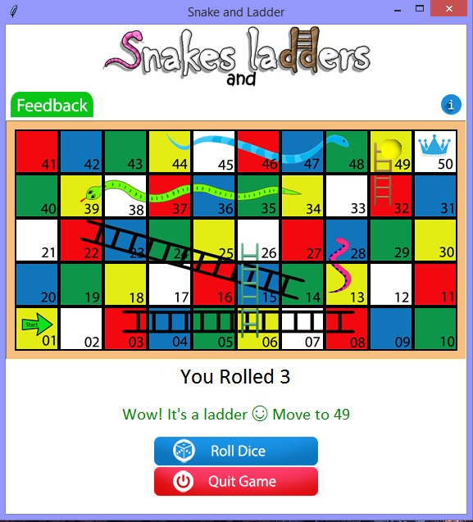

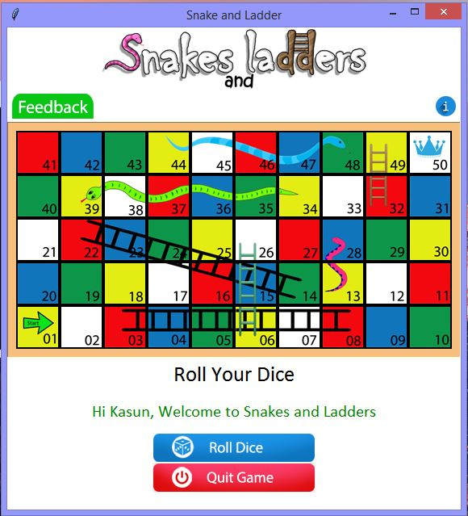

02. Snake 04. After reach 50th position

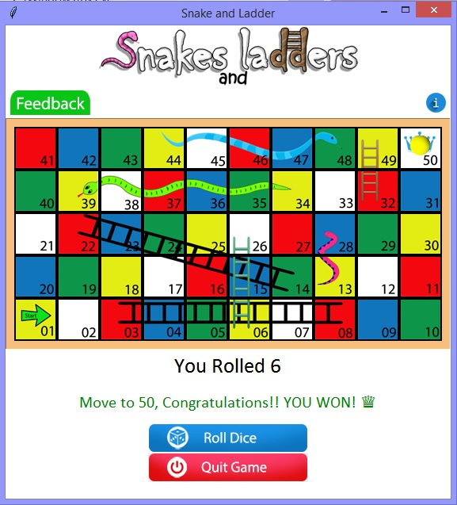

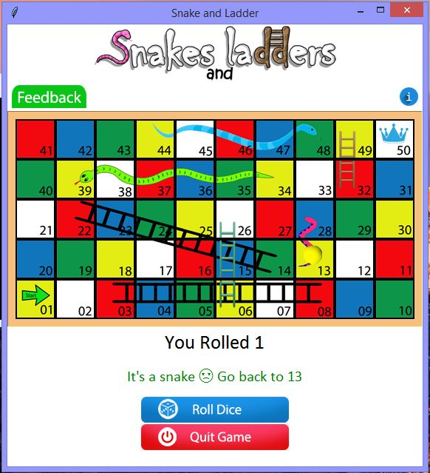

05. Feedback window 06. Introduction

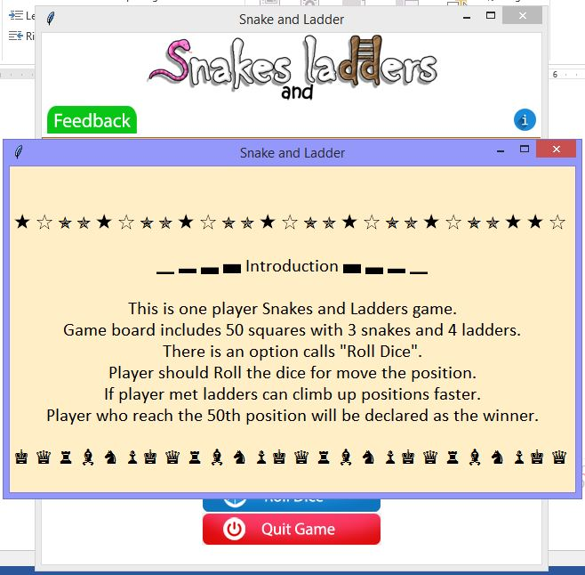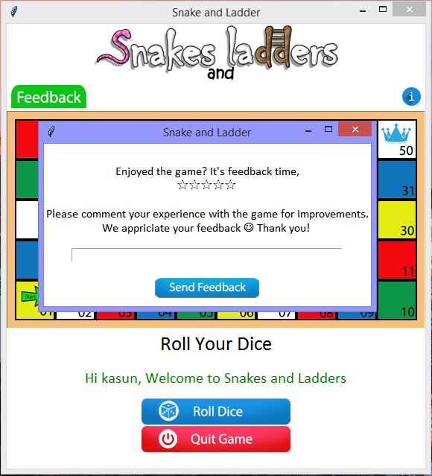

07. Player name

